**Lab3 Advanced Sql**

**Q1:** **Insert new student and his score in exam in different subjects as transaction.**

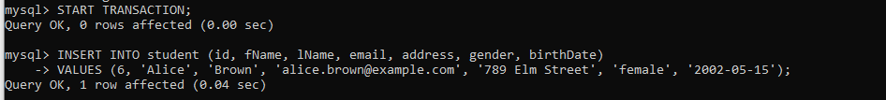

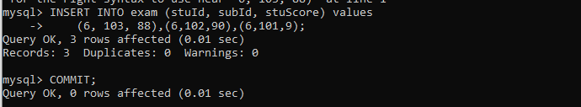

**Q2:** **Display the date of exam as the following: day 'month name' year.**

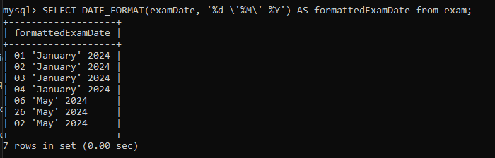

**Q3:** **Display name and age of each students**

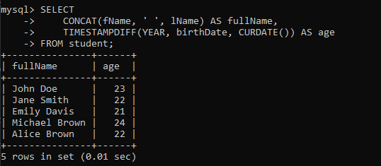

**Q4:** **Display the name of students with their Rounded score in each Exam**

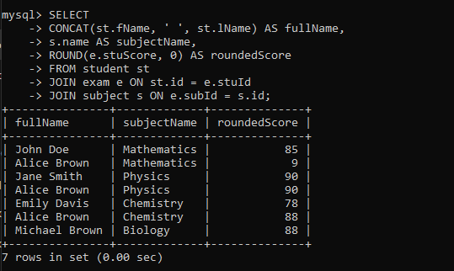

**Q5:** **Display the name of students with the year of Birthdate**

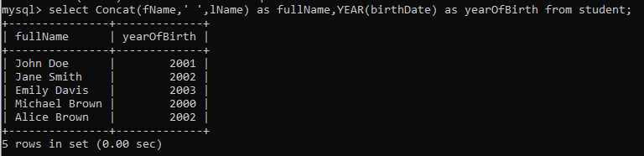

**Q6:** **Add new exam result, in date column use NOW**



**Q7:** **Create Hello world function which take username and return welcome message to user using his name**

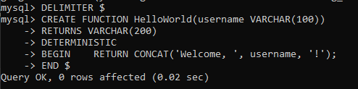

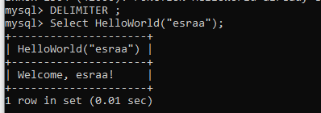

**Q8:** **Create multiply function which take two number and return the multiply of them**

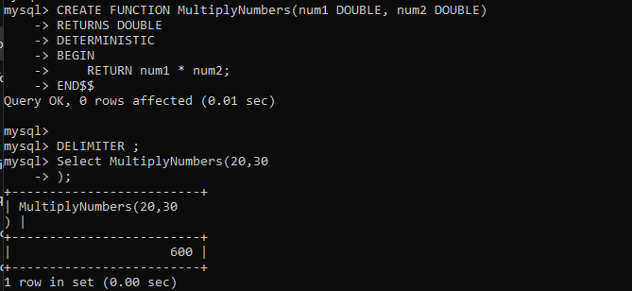

**Q9:** **Create function which takes student id and Exam id and return score the student in Exam.**

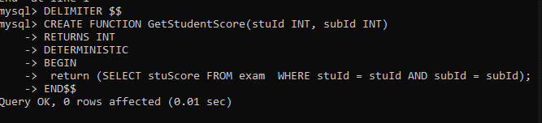

**Q10:** **Create function which takes Exam id and return the number of students who failed in a Exam (Score less than 50).**

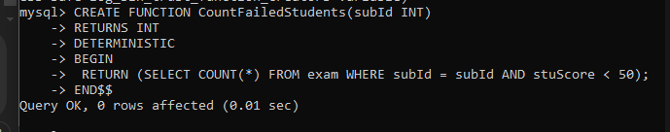

**Q11:** **Create function which take subject name and return the average of max grades for subject**

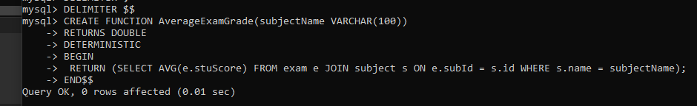

**Q12:** **Create Table called Deleted_Students which will hold the deleted students info(same columns as in student tables)**

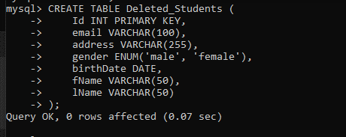

**Q13:** **Create trigger to save the deleted student from Student table to Deleted_Students.**

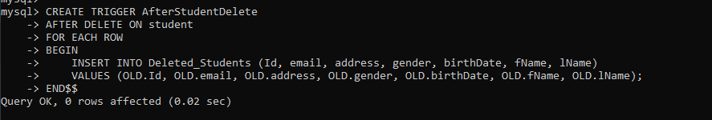

**Q14:** **Create trigger to save the newly added students to Student table to Backup_Students.**

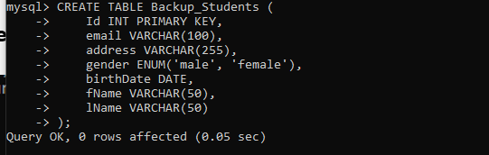

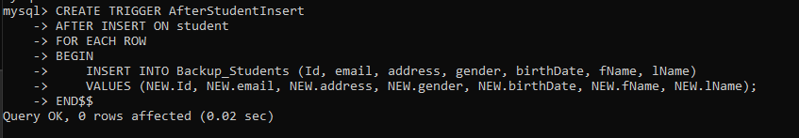

**Q15:** **(Bouns) Create trigger to keep track the changes of contact info table**

**(add/update rows); it will logs the time of action and description of**

**action to another table.**

**1.create table**

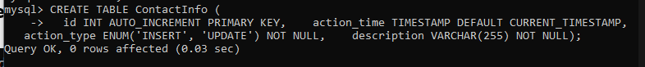

**2.trigger insert**

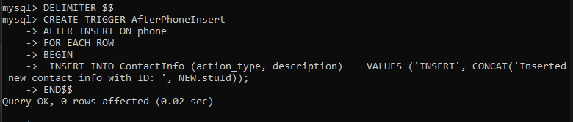

**3.trigger update**

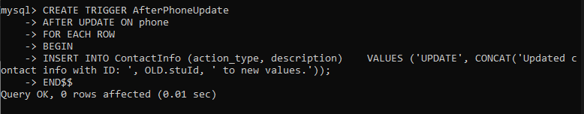

**Q16:** **Dump your database into SQL file.**





**Q17:** **Dump Students table into file.**





**Q18:** **Import SQL file into your backup database (Grading_Backup Database)**





